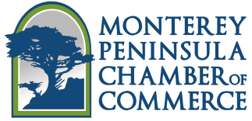

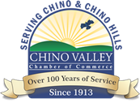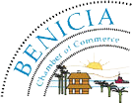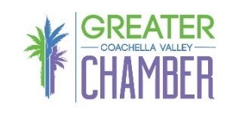

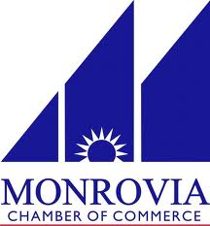

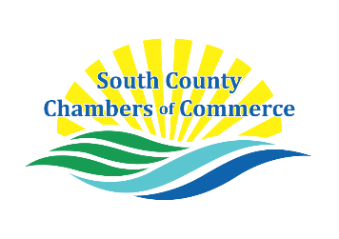



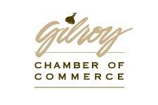

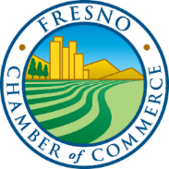

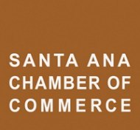



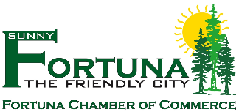



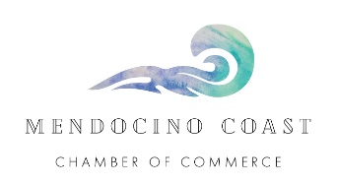



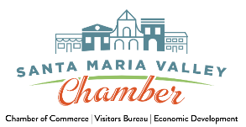[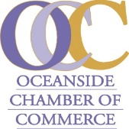](http://oceansidechamber.tumblr.com/)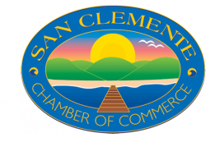

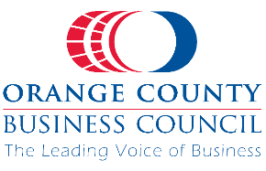

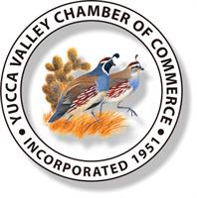









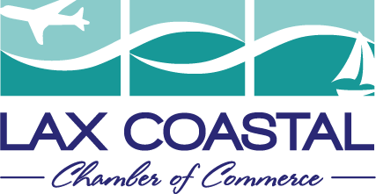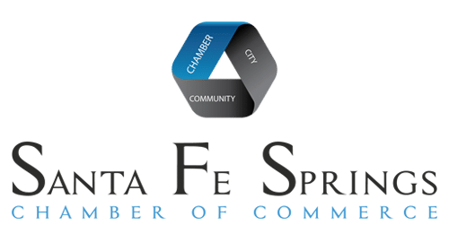

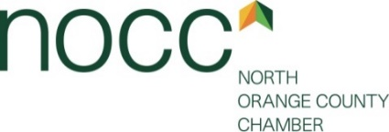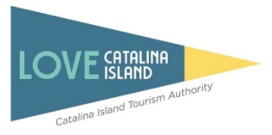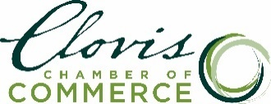

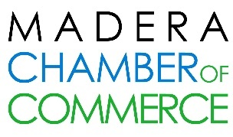

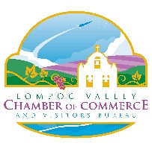

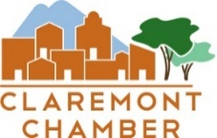





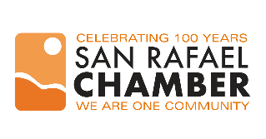

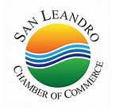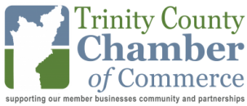

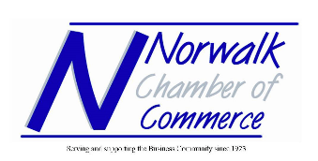

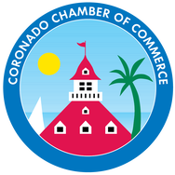

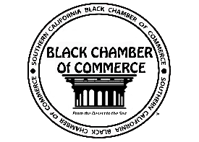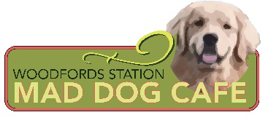

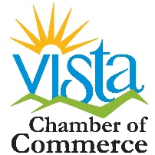



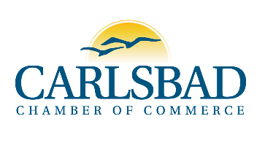







cid:image001.jpg@01D067E1.7EA501B0

December 3, 2020

TO: CA Congressional Delegation and CA Senators

**SUBJECT: FEDERAL RELIEF FOR SMALL BUSINESSES DUE TO COVID-19 PANDEMIC**

Dear CA Senators and Representatives:

The California Chamber of Commerce and other organizations listed below represent small businesses throughout California in every industry of the economy and provide hundreds of thousands of jobs that support California workers and their families. We are requesting immediate federal relief to save small businesses in our state who are fighting to survive in the midst of the COVID-19 pandemic.

In California, small businesses are struggling to make payroll and a significant number are closing altogether. As recently reported in the Los Angeles Times, California’s small business revenue was down by 29.3% in November compared with January 2020, and the number of small businesses open has dropped by 28.8%. With the most recent surge in COVID19 infection that has pushed our hospitals to their maximum capacity, Governor Newsom has issued a renewed shelter in place order that we believe will be catastrophic to the remaining small businesses throughout the state.

Many small businesses depend upon the higher volume of sales during the holiday season to help them throughout the year. Depending upon the product or service they provide, small businesses are either operating at limited capacity or completely shut down and those expected sales will never materialize. To address this emergency, we request the following actions to be taken immediately.

First, extend and expand the Paycheck Protection Program (PPP) to provide small businesses with much needed, non-taxable, financial relief. The PPP successfully helped small businesses avoid shutting down as a result of the initial shelter in place orders and can provide that same relief now. We would urge you to allow small businesses to utilize the funding received under the PPP for all businesses related expenses while still allowing the business to qualify for loan forgiveness and to make PPP revenues tax exempt.

Second, we request forgiveness of the federal loan California has received for unemployment benefits, which is now approximately $20 billion and expected to grow as a result of the recent shelter in place order. California employers will ultimately be responsible for paying this loan back through a reduced Federal Unemployment Insurance Tax Act (FUTA) credit. This essentially is a tax increase on all employers, including small businesses that can least afford it.

Third, we respectfully request that any federal stimulus and aid package include emergency financial support for 501(c)(6) associations, such as state and local chambers of commerce. As the businesses they serve lose revenue, so will these important organizations. Many small businesses rely on these organizations to provide critical information and support during this pandemic and therefore it is essential for these organizations to receive relief.

We appreciate your immediate attention to our request and your efforts to help save the small businesses in California.

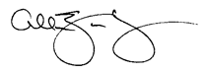Sincerely,

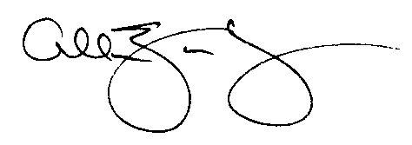

Allan Zaremberg

California Chamber of Commerce

Alhambra Chamber of Commerce

Alpine County Chamber of Commerce

Arcata Chamber of Commerce

Bear Valley Adventure Company

Bear Valley Music Festival

Benicia Chamber of Commerce

Berkeley Chamber of Commerce

Big Bear Chamber of Commerce

Bishop Area Chamber of Commerce & Visitors Bureau

Brawley Chamber of Commerce

Brea Chamber of Commerce

Carlsbad Chamber of Commerce

Carmel Chamber of Commerce

Catalina Island Tourism Authority

Century City Chamber of Commerce

Chino Valley Chamber of Commerce

Claremont Chamber of Commerce

Clovis Chamber of Commerce

Corona Chamber of Commerce

Coronado Chamber of Commerce

Crescent City/Del Norte Chamber of Commerce & Del Norte Visitor Bureau

Cupertino Chamber of Commerce

Cutthroat Brewing Company LLC

Dana Point Chamber of Commerce

David Griffith – Alpine County Dist 5 Supervisor

Dublin Chamber of Commerce

El Centro Chamber of Commerce & Visitors Bureau

El Dorado County Chamber of Commerce

Escondido Chamber of Commerce

Fortuna Chamber of Commerce

Freemont Chamber of Commerce

Fresno Chamber of Commerce

Gilroy Chamber of Commerce

Glendale Chamber of Commerce

Glendora Chamber of Commerce

Greater Bakersfield Chamber of Commerce

Greater Coachella Valley Chamber of Commerce

Greater Concord Chamber of Commerce

Greater Conejo Valley Chamber of Commerce

Greater Riverside Chambers of Commerce

Greater San Fernando Valley Chamber of Commerce

Greater Stockton Chamber of Commerce

Greater Tehachapi Chamber of Commerce

Hawthorne Chamber of Commerce

Imperial Valley Joint Chambers of Commerce

Industry Business Council

Laguna Niguel Chamber of Commerce

Lake Elsinore Valley Chamber of Commerce

LAX Coastal Chamber of Commerce

Lompoc Valley Chamber of Commerce

Long Beach Area Chamber of Commerce

Los Angeles Area Chamber of Commerce

Los Gatos Chamber of Commerce

Mad Dog Cafe

Madera Chamber of Commerce

Manhattan Beach Chamber of Commerce

Mendocino Coast Chamber of Commerce

Monrovia Chamber of Commerce

Montebello Chamber of Commerce

Monterey Peninsula Chamber of Commerce

North Orange County Chamber

North San Diego Business Chamber

Norwalk Chamber of Commerce

Oceanside Chamber of Commerce

Orange County Business Council

Oxnard Chamber of Commerce

Paradise Ridge Chamber of Commerce

Pleasanton Chamber of Commerce

Rancho Cordova Chamber of Commerce

Rancho Mirage Chamber of Commerce

Regional Chamber of Commerce – San Gabriel Valley

Ridgecrest Chamber of Commerce

Roseville Area Chamber of Commerce

Sacramento Metropolitan Chamber of Commerce

San Clemente Chamber of Commerce

San Francisco Chamber of Commerce

San Leandro Chamber of Commerce

San Rafael Chamber of Commerce

San Ramon Chamber of Commerce

Santa Ana Chamber of Commerce

Santa Fe Springs Chamber of Commerce & industrial League, Inc.

Santa Maria Chamber of Commerce

Santa Rosa Metro Chamber of Commerce

Santa Paula Chamber of Commerce

South County Chambers of Commerce

South County Economic Coalition

Southern California Black Chamber of Commerce

Sunnyvale Silicon Valley Chamber of Commerce

The Newport Beach Chamber of Commerce

The Silicon Valley Organization

Torrance Area Chamber of Commerce

Trinity County Chamber of Commerce

Truckee Chamber of Commerce

Ventura Chamber of Commerce

Vista Chamber of Commerce

West Hollywood Chamber of Commerce

West Valley – Warner Center Chamber of Commerce

Whittier Area Chamber of Commerce

Yorba Linda Chamber of Commerce

Yucca Valley Chamber of Commerce

AZ:ll

